Make: Wilkhahn
Model: ON swivel chair
Design: wiege

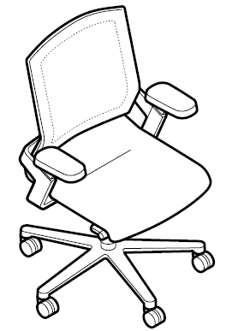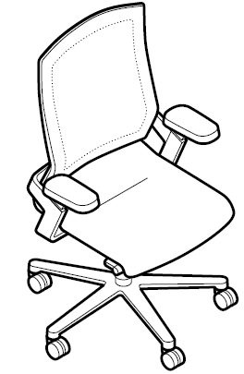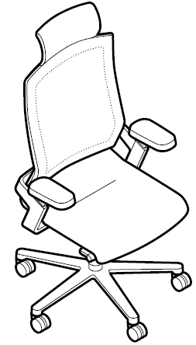

Models:
174/7 medium-height backrest
175/7 high backrest
175/7 high backrest with headrest
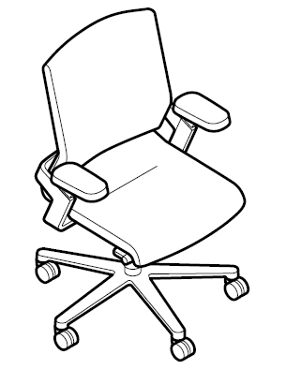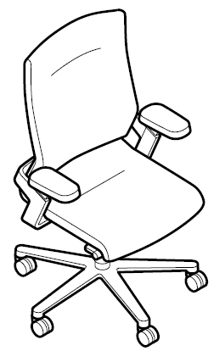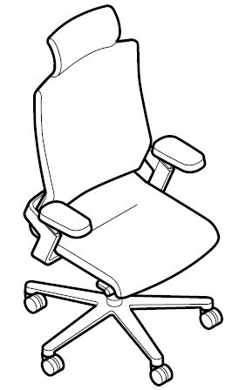
Models:
174/71 medium height backrest, Management type
175/71 high backrest, Management type
175/71 high backrest with headrest, Management type

Standards / quality labels:
DIN EN 1335, type A or B office chair
GS standard (safety tested)
ANSI/BIFMA X5.1
Ergonomics tested
Optional: NPR 1813

Chair dimensions:
Seating height: 40-52 cm infinitely adjustable
Total height: (model 174/7) 97-109 cm
Total height: (model 175/7) 105-117 cm
Total height: (model 175/7 with headrest height 16 cm) 121 – 133 cm
Width: 69 cm (Model 174/7 and 174/71), 70 cm (Model 175/7 and 175/71)
Depth: 66 cm
The seating height is measured under load with DIN equipment
Total height, width and depth are the minimum dimensions

Weight:
From 19.5 kg to 20.5 kg (depending on the model and design without packaging)

Description:
Swivel chairs with integrated, synchro-supporting, three-dimensional kinematics
Synchro-adjustment technology, seat and back automatically adapt to any movement and posture of the person sitting on the chair to foster supported, three-dimensional dynamic sitting
Synchronous forwards and backwards movements from -12° to + 3°
Opening angle in the seat up to 28° tilt in the back
Seat and back tilt sideways up to 13°, supporting counter pressure in any direction quickly infinitely adjustable (max. 5.5 rotations): for people weighing between 45 – 120 kg
Backrest height adjustable by up to + 60 mm in six lockable positions
Backrest and seat can be locked in the front sitting position
The seat height is infinitely adjustable at the touch of a button between 400 mm and 520 mm with a DIN 4550-compliant gas lift
All models optionally available with seat-depth adjustment of 400 to 450 mm

Mechanism:
The core principle of the mechanism is to mirror the flexibility and position of the knee and hip joints, enabling a natural, three-dimensional range of movement while maintaining the body’s centre of gravity in any position
The shell for the mechanism is made of shot-blasted die-cast aluminium with a through-dyed black polypropylene cover
Optional: shell for the mechanism coated in black or silver satin finish
Coated (black or silver satin finish) die-cast aluminium swivel arms, two per chair can be moved independently of one another, the counter pressure is infinitely adjustable near the knees via a two-dimensional flexible main axis which results in three-dimensional, flexible suspension between the highly elastic seat shell and back frame
Optional: die-cast aluminium, polished or bright chrome-plated

Frame:
Five-star base, 72 cm in diameter made of black, through-dyed, glass fibre-reinforced polyamide
Optional: die-cast aluminium, coated (black or silver satin finish)
Optional: die-cast aluminium, polished or bright chrome-plated
Twin wheel swivel castors with load-dependent braking, made of black polyamide in accordance with DIN EN 12429 as the standard version for carpets
Optional: with grey polyurethane coating for hard flooring
Optional: electrically conductive castors
Gas lift covered by telescopic protective tube made of black through-dyed polypropylene

Seat:
Highly elastic, flexibly suspended seat shell with seat upholstery panel made of black, through-dyed polypropylene
Optional: seat-depth adjustment from 400 to 450 mm (all types of upholstery, except for types with extra padding)
Seat can be exchanged
Seat cushions made of polyurethane, covered in the same material as the backrest frame in Fiberflex, colours from the Wilkhahn Fiberflex sample card
Optional: extra padding made of layered foam, only available when seat is covered with Fiberflex and without seat-depth adjustment
Optional: fabric cover from the Wilkhahn fabric collection
Optional: fabric cover to suit customer preferences, if required Wilkhahn will check fabric’s suitability

Management grade upholstery (models 174/71, 175/71)
Seat cushions with additional padding and side facings
Fabric cover from the Wilkhahn fabric collection
Optional: leather cover from the Wilkhahn leather collection
Optional: fabric or leather cover as desired, if required Wilkhahn will check material’s suitability

Back:
Elastic back frame, linked three-dimensionally and flexibly with the swivel arms, both of which can be moved independently of one another and the seat shell, lockable in six positions, height-adjustable by 60 mm (520-580 mm) made of through-dyed, glass fibre-reinforced polyamide
Medium-height backrest (models 174/7 and 174/71)
High backrest (models 175/7 and 175/71)
Optional: high backrest (models 175/7 and 175/71) with headrest (height 16 cm), headrest either in the same material as the backrest cover or covered in leather on the front
Back can be exchanged
Back covered in the same material as the seat cover in Fiberflex, colours from the Wilkhahn Fiberflex sample card
Optional: extra padding made of cut foam fleece only available when backrest is covered with Fiberflex and without seat-depth adjustment
Optional: fabric cover from the Wilkhahn fabric collection (with additional padding)
Optional: fabric cover to suit customer preferences (with additional padding), if required Wilkhahn will check material’s suitability

Management grade upholstery (models 174/71, 175/71)
Backrest with additional padding, front of backrest also with concealed, cut foam fleece and padding sewn into the cover and with side facings
Fabric cover from the Wilkhahn fabric collections
Optional: leather cover from the Wilkhahn leather collections
Optional: fabric or leather cover as desired, if required Wilkhahn will check material’s suitability

Cushioning:
All foam used is CFC-free

Shipment method:
Fully assembled in a box, or using the knock-down method
Packaging sizes:
174/7 medium-height backrest: standard 128 x 72.4 x 72.4 cm; knock-down: 71.5 x 67.0 x 70.5 cm
175/7 high backrest: standard 128 x 72.4 x 72.4 cm; knock-down: 71.5 x 67.0 x 70.5 cm
175/7 high back with headrest: standard 128 x 72.4 x 72.4 cm; knock-down version not available
Knock-down method: cuts the volume transported and saves space in the warehouse compared with other conventional methods by approx. 45%
Tool-free assembly of the backrest
Customers can save storage space required for spare chairs and different styles of backrests

Armrests:
Three-dimensional armrests made of glass fibre-reinforced, black through-dyed polyamide, integrated into the armrests each of which can be moved independently from one another
Sizes of armrest pads: width: 105 mm, depth: 205 mm, height: 25 mm
Armrest pads made of black, through-dyed polyurethane
Optional: polyurethane foam armrest pads
Optional: upholstered armrest pads with leather covers from the Wilkhahn leather collection
Height of armrests adjustable by 100 mm (eight lockable positions), depth by 40 mm, armrests can be swivelled 30° inwards and outwards
Optional: without armrests, armrest covers made of black through-dyed polypropylene
Armrests can be retrofitted at any time

Environmental product information:
Materials used approx.: aluminium 33.0%, steel 18.5%, zinc 2.5%, plastics 46.0%
Returns, disassembly and recycling:
All ON swivel-chair components are suitable for non-destructive disassembly. In order to guarantee materials are sorted according to type, all components over 150 g in weight are labelled. No agents to protect materials, or organic halogen compounds are used that prevent recycling at a later date. A total of 98 per cent of the chair can be recycled.
For further information visit: http://www.wilkhahn.com/en/about/corporate-responsibility/

Certification and awards:
UN Global Compact
ISO 9001
ISO 14001
EMAS
GREENGUARDTM (certified version available on request)
AFRDI Green Tick Product Certification Standard 150, Level A – Platinum
AFRDI Blue Tick Product Certification based on AS/NZS 4438 – Level 6
LEED
The following LEED ratings can be achieved:
LEED CI 5 – 7
LEED NC 4
LEED EB 7

International design awards:
2010: iF product design award 2010, Hanover
2010: Australian International Design Award 2010, Sydney: "Furniture and Interior Products" category
2010: Mix Interior Award 2010, London: "Furniture" category
2010: Best of NeoCon 2010, Chicago: "Best of Competition", best product at the trade show in all categories
2010: Best of NeoCon 2010, Chicago: "Gold Winner", best product in the "Office chair/ergonomics" category
2010: Best of NeoCon 2010, Chicago: "Silver Winner", in the "Seating/Conference" category
2010: Best of NeoCon 2010, Chicago - People's Choice Awards 2010: "Silver Winner", in the "Seating/Conference" category
2010: FX International Interior Design Awards, ''Product of the year 2010''
2010: Good Design Award 2010, Chicago
2010: Good Design Award 2010, Japan
2011: Universal Design Award 2011, Hanover
2011: German Design Prize 2011, Silver
2011: Universal Design Award 2011, Consumer Favorite, Hanover
2012: Federal Ecodesign Award Product 2012

Wilkhahn reserves the right to make technical changes to the information provided.
May 2015 version

