Make: Wilkhahn
Model: ON conference/visitor cantilever chair
Design: wiege

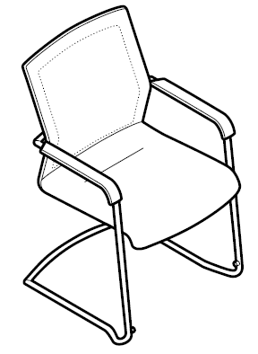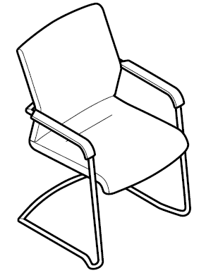

Models:
178/7 standard height backrest (stackable)
178/71 standard height backrest, Management type (not stackable)

Standards / quality labels:
DIN EN 13761
DIN EN 1022
GS standard (safety tested)
ANSI/BIFMA X5.1

Chair dimensions:
Seating height: 43 cm
Total height: 92 cm
Width: 61 cm
Depth: 60 cm
The seating height is measured under load with DIN equipment
Total height, width and depth are the minimum dimensions

Weight:
178/7 kg standard height backrest 9.5 kg (depending on the model and design without packaging)
178/71 standard height backrest, Management type: 10.0 kg (depending on the model and design without packaging)

Description:
Understated, formal conference/visitor cantilever chair
Up to five can be stacked freestanding, up to eight on a four-wheeled trolley

Frame:
Frame made of bright chrome-plated steel tubing, 22 mm in diameter
Stretcher 16 mm in diameter
Standard design: black polyamide glides for carpets
Optional: polyurethane glides for hard flooring
Optional: polyamide glides with additional felt (e.g. for wooden or stone flooring susceptible to scratches)
Small black through-dyed plastic parts

Seat:
Unitary shell-frame design made of through-dyed, glass fibre-reinforced polypropylene
Seat can be exchanged
Seat cushions made of polyurethane one-piece moulded foam, covered in the same material as the backrest frame in Fiberflex, colours from the Wilkhahn Fiberflex sample card
Optional: fabric cover from the Wilkhahn fabric collection
Optional: fabric cover to customer’s specifications, if required Wilkhahn will check fabric’s suitability

Management grade upholstery (models 178/71)
Seat cushions with additional padding and side facings
Fabric cover from the Wilkhahn fabric collection
Optional: leather cover from the Wilkhahn leather collection
Optional: fabric or leather cover to suit customer preferences, if required Wilkhahn will check material’s suitability

Back:
Elastic backrest frame made of through-dyed, glass fibre-reinforced polyamide
Covers and cushions are replaceable
Back covered in the same material as the seat cover in Fiberflex, colours from the Wilkhahn Fiberflex sample card
Optional: fabric cover from the Wilkhahn fabric collection (with additional padding)
Optional: fabric cover to suit customer preferences (with additional padding), if required Wilkhahn will check material’s suitability

Management grade upholstery (models 178/71)
Backrest upholstery with additional padding, front of backrest also with concealed, cut foam fleece sewn into the cover and with side facings
Fabric cover from the Wilkhahn fabric collection
Optional: leather cover from the Wilkhahn leather collections
Optional: fabric or leather cover to suit customer preferences, if required Wilkhahn will check material’s suitability

Cushioning:
All foam used is CFC-free

Shipment method:
Fully assembled in a box
Packaging sizes:
178/7 standard height backrest: 75 x 73 x 98 cm
178/71 standard height backrest, Management type: 75 x 73 x 98 cm

Armrests:
Rigid armrests made of glass fibre-reinforced, black, through-dyed polypropylene
Optional: with upholstered armrest pads with leather 74/99, black when covered with fabric (not stackable)
Optional: with upholstered armrest pads to match the colour of the leather if leather covers are chosen (not stackable)

Environmental product information:
Material used: plastics: 38%, steel 60%, wood-based products 2%
Returns, disassembly and recycling:
All components in the ON conference/visitor chair are suitable for non-destructive disassembly.
(The seat cushion is glued to the seat upholstery panel and the fabric is stapled to the seat upholstery panel).
In order to guarantee materials are sorted according to type, all components over 150 g in weight are labelled. No agents to protect materials, or organic halogen compounds are used that prevent recycling at a later date. A total of 93 per cent of the chair can be recycled.
For further information visit: http://www.wilkhahn.com/en/about/corporate-responsibility/
The following LEED ratings can be achieved:
LEED CI 5 – 7
LEED NC 4
LEED EB 7

Accessories:
For cantilever model 178/7:
four-wheeled trolley model 178 for 8 cantilever chairs

Certification and awards for the ON product family (depending on the model):
UN Global Compact
ISO 9001
ISO 14001
EMAS
GREENGUARDTM (certified version available on request)
AFRDI Green Tick Product Certification Standard 150, Level A – Platinum
AFRDI Blue Tick Product Certification based on AS/NZS 4438 – Level 6
LEED

International design awards for the ON product family:
2010: iF product design award 2010, Hanover
2010: Australian International Design Award 2010, Sydney: "Furniture and Interior Products" category
2010: Mix Interior Award 2010, London: "Furniture" category
2010: Best of NeoCon 2010, Chicago: "Best of Competition", best product at the trade show in all categories
2010: Best of NeoCon 2010, Chicago: "Gold Winner", best product in the “Office chair/ergonomics” category
2010: Best of NeoCon 2010, Chicago: "Silver Winner", in the "Seating/Conference" category
2010: Best of NeoCon 2010, Chicago - People's Choice Awards 2010: "Silver Winner", in the "Seating/Conference" category
2010: FX International Interior Design Awards, ''Product of the year 2010''
2010: Good Design Award 2010, Chicago
2010: Good Design Award 2010, Japan
2011: Universal Design Award 2011, Hanover
2011: German Design Prize 2011, Silver
2011: Universal Design Award 2011, Consumer Favorite, Hanover
2012: Federal Ecodesign Award Product 2012

Wilkhahn reserves the right to make technical changes to the information provided.
September 2014 version

